Microsoft Azure - Starter Kits for Partners

Statement of Work (Sample)

SharePoint on Azure Virtual Machines

Last Update: September 2015





**MICROSOFT MAKES NO WARRANTIES, EXPRESS, IMPLIED OR STATUTORY, AS TO THE INFORMATION IN THIS DOCUMENT.**

The information contained in this document represents the current view of Microsoft Corporation on the issues discussed as of the date of publication. Because Microsoft must respond to changing market conditions, it should not be interpreted to be a commitment on the part of Microsoft, and Microsoft cannot guarantee the accuracy of any information presented after the date of publication.

Complying with all applicable copyright laws is the responsibility of the user. Without limiting the rights under copyright, no part of this document may be reproduced, stored in or introduced into a retrieval system, or transmitted in any form or by any means (electronic, mechanical, photocopying, recording, or otherwise), or for any purpose, without the express written permission of Microsoft Corporation.

Microsoft may have patents, patent applications, trademarks, copyrights, or other intellectual property rights covering subject matter in this document. Except as expressly provided in any written license agreement from Microsoft, the furnishing of this document does not give you any license to these patents, trademarks, copyrights, or other intellectual property.

The descriptions of other companies’ products in this document, if any, are provided only as a convenience to you. Any such references should not be considered an endorsement or support by Microsoft. Microsoft cannot guarantee their accuracy, and the products may change over time. Also, the descriptions are intended as brief highlights to aid understanding, rather than as thorough coverage. For authoritative descriptions of these products, please consult their respective manufacturers.

© 2015 Microsoft Corporation. All rights reserved. Any use or distribution of these materials without express authorization of Microsoft Corp. is strictly prohibited.

Microsoft and Windows are either registered trademarks of Microsoft Corporation in the United States and/or other countries.

The names of actual companies and products mentioned herein may be the trademarks of their respective owners.

Contents

Overview 5

Scenario Overview 7

Why SharePoint 2013 in Microsoft Azure? 7

Test and development environments 7

Internet Facing Sites 7

SharePoint in Azure for Disaster Recovery 7

The Proposed Solution 8

Azure Infrastructure Estimated Price 9

Fee Schedule 9

Scope of Work 9

Areas Out of Scope 11

Period of Performance 11

Engagement Resources 11

[Company Name] Project Roles and Responsibilities 11

Customer Project Roles and Responsibilities 12

Delivery Methodology 12

Deliverable Materials 13

General Customer Responsibilities and Project Assumptions 13

General Customer Responsibilities 13

Project Assumptions 14

Conditions of Satisfaction 14

Suggested Sections/Topics to be added by the Partner 15

# Overview

The purpose of this document is to provide Microsoft Partners with a **sample** Statement of Work (SOW) that they can use as a reference to propose to their customers an engagement for deploying SharePoint 2013 in Azure Virtual Machines scenario.

Although this sample aim at facilitating and accelerating your engagements, Microsoft makes no warranty that using this template will result in a successful project, you are responsible for defining the conditions of satisfaction with your customer and delivering the proposed scenario.

In this document, we cover the following topics:

* SOW CONTRACT TEMPLATE
* THE PROPOSED SOLUTION
* FEE SCHEDULE
* SCOPE OF WORK
* AREAS OUT OF SCOPE
* PERIOD OF PERFORMANCE
* ENGAGEMENT RESOURCES
* DELIVERY METHODOLOGY
* DELIVERABLE MATERIALS
* GENERAL CUSTOMER RESPONSIBILITIES AND PROJECT ASSUMPTIONS
* CONDITIONS OF SATISFACTIOM

|  |  |
| --- | --- |
| [Company Name]  [Company Address] [City, ST ZIP Code] | Logo |

SOW [000] for Agreement to Perform Consulting Services to [Client Name]

Statement of Work

|  |  |  |
| --- | --- | --- |
| Date | Services Performed By: | Services Performed For: |
| [Date] | [Company Name]  [Company Address] [City, ST ZIP Code] | [Client Name]  [Client Address] [City, ST ZIP Code] |

|  |  |
| --- | --- |
|  | Placeholders for your content that appear in the paragraph text are shown in red and will change to the default text color when you add your content. Information that repeats in the document (such as client name) will be updated in all locations when you add or edit it once.  The text provided is sample SOW text that you can edit as applicable for your business.  Note: to delete any tip, such as this one, just click the tip text and then press the spacebar. |

This Statement of Work (SOW) is issued pursuant to the Consultant Services Master Agreement between [Client Name] (“Client”) and [Company Name] (“Contractor”), effective [Click to select date] (the “Agreement”). This SOW is subject to the terms and conditions contained in the Agreement between the parties and is made a part thereof. Any term not otherwise defined herein shall have the meaning specified in the Agreement. In the event of any conflict or inconsistency between the terms of this SOW and the terms of this Agreement, the terms of this SOW shall govern and prevail.

This SOW # [000] (hereinafter called the “SOW”), effective as of [Click to select date], is entered into by and between Contractor and Client, and is subject to the terms and conditions specified below. The Exhibit(s) to this SOW, if any, shall be deemed to be a part hereof. In the event of any inconsistencies between the terms of the body of this SOW and the terms of the Exhibit(s) hereto, the terms of the body of this SOW shall prevail.

In this project, [Company Name] (“Contractor”) will assist you with building a lab solution in Microsoft Azure.

This solution delivers a three-tiered highly available SharePoint 2013 farm running on Microsoft Azure. The solution will include two Domain Controllers, two SharePoint Web Server, two SharePoint Application Servers and two Database Server running SQL 2012 configured with AlwaysOn Availability Groups. [Company Name] Will assist in the design, deployment, and set up of the solution and leads solution walk through with customer staff.

# Scenario Overview

## Why SharePoint 2013 in Microsoft Azure?

SharePoint solutions can be hosted in Microsoft Azure Infrastructure Services. For most cases like intranet or internal collaboration workloads Office 365 is the first recommended option but in some scenarios such as Internet Sites, Disaster Recovery or test and development environments Azure Infrastructure Services is actually a recommended solution.

### Test and development environments

Rapidly self-provision as many virtual machines as you need for your test or development SharePoint farm in the cloud without waiting for hardware, procurement or internal processes. You can easily scale up and out to mimic your production environment and more accurately test and faster deliver your applications. Once you are done simply remove all used resources and save money.

### Internet Facing Sites

Using Microsoft Azure Infrastructure Services to host SharePoint for Internet facing sites allows you scale your solution according to any fluctuation on demand, use and take advantage of any features not present in Office 365 as well as leveraging other Azure Services such as Azure Active Directory for customer or partner accounts. Focus on developing your external internet-facing site, start small and grow as you need without worrying on building and maintaining infrastructure.

### SharePoint in Azure for Disaster Recovery

A disaster recovery environment for SharePoint is expensive to build and maintain on-premises. Using the advantages of Azure Infrastructure Services you can easily build flexible and affordable disaster recovery sites that are much easier to maintain and can easily scale out to meet load requirements if disaster strikes. Once not in use, scale in to use a set of minimum resources depending on your hot, warm, cold disaster recovery strategy and keep it updated.

Azure also provides several services that can be used to complement or extent any of these scenarios. Some of these services include Azure Virtual Network, Mobile Services, Cloud Services, SQL Databases, and Azure Storage.

# The Proposed Solution

You can leverage Azure as the infrastructure for your SharePoint Farm in any of the solution above.

For this engagement, we are covering the build and setup of a highly available SharePoint 2013 farm using Azure Infrastructure Services.

EXTRACTED FROM ARCHITECTURE VISIO DOCUMENT– UPDATE IF ARCHITECTURE CHANGES

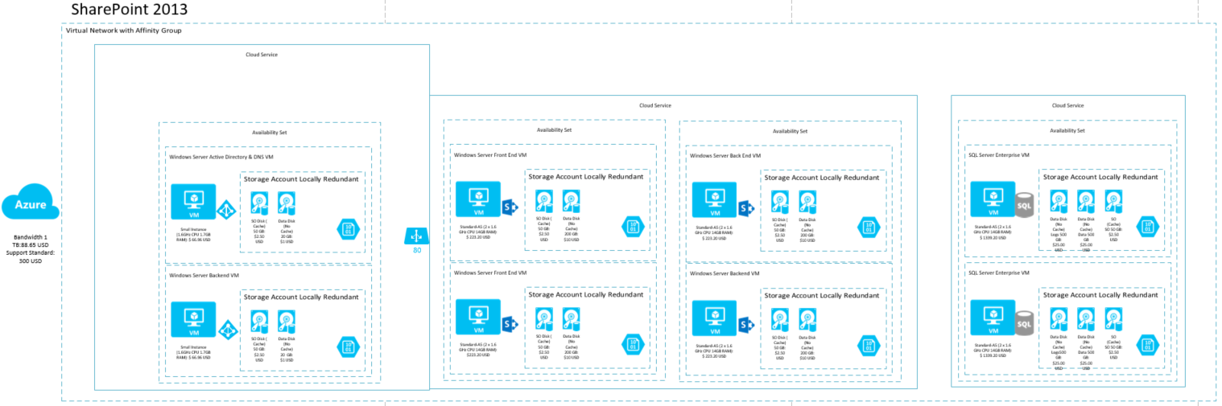

## Azure Infrastructure Estimated Price

If your company owns a MSDN subscription, you can enjoy up to $150 in credits on Azure with reduced Windows Server rates and use your MSDN software such as SQL Server and SharePoint for no **additional licensing fee** for your Dev and Test scenarios. For other scenarios please check you licensing rights.

EXTRACTED FROM COST ESTIMATOR DOCUMENT– UPDATE IF ARCHITECTURE CHANGES

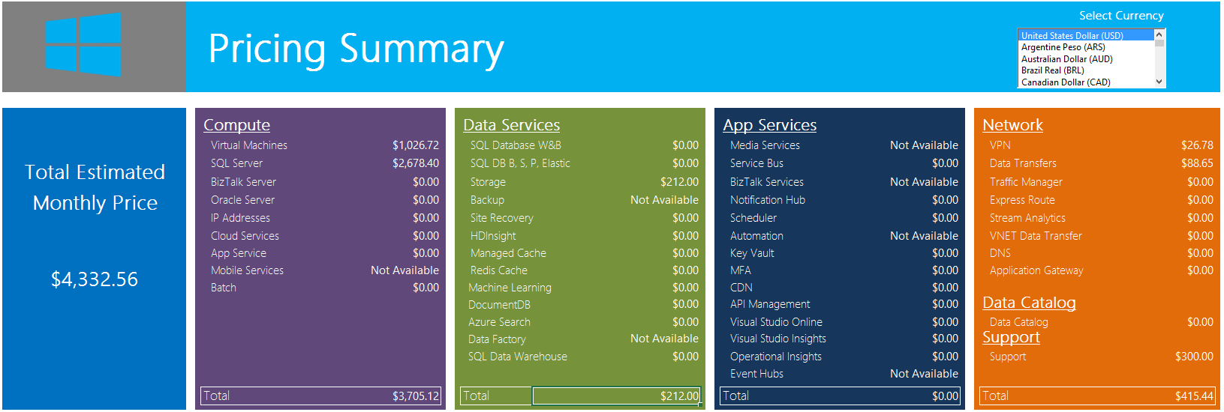

* The price can be reduced in **$2678 USD** if you already have two SQL Server Enterprise Licenses with License Mobility that can be used in Azure.
* SharePoint licenses not included

# Fee Schedule

This engagement will be conducted on a Time & Materials basis. The total value for the Services pursuant to this SOW shall not exceed [$000] unless otherwise agreed to by both parties via the project change control procedure, as outlined within. A PCR will be issued specifying the amended value.

# Scope of Work

In this project, [Company Name] (“Contractor”) will assist you with building a SharePoint 2013 farm running in Microsoft Azure. This solution delivers a three-tiered highly available SharePoint 2013 farm running on Microsoft Azure. The solution will include two Domain Controllers, two SharePoint Web Server, two SharePoint Application Servers and two Database Server running SQL 2012 configured with AlwaysOn Availability Groups. [Company Name] Will assist in the design, deployment, and set up of the solution and leads solution walk through with customer staff.

**Note:** You can leverage Azure as the infrastructure for your SharePoint Farm in any of the solution above.

For this engagement, we are covering the build and setup of a SharePoint 2013 farm using Azure Infrastructure Services.

|  |  |
| --- | --- |
| Work Item | Scope |
| General technical deployment guidance provided by [Company Name] | |
| Activities/Tasks | 1. Assessment Phase    * Review technical requirements for the project and perform assessment and remediation tasks accordingly 2. Configure Microsoft Azure    * Create Microsoft Azure Tenant (if needed)    * Create admin and co-admins    * Create Virtual Network    * Create Cloud Services    * Create Azure Storage Account 3. Configure Domain Controller    * Create the two DC Virtual Machines in Azure    * Create availability set for DC VMs    * Create, attach and initialize data disk in each DC VM    * Install Domain Controller and Active Directory    * Create user accounts for SharePoint and SQL 4. Configure SQL Server Infrastructure    * Create the two SQL Virtual Machines in Azure    * Create availability set for SQL VMs    * Create, attach and initialize data disk in each SQL VM    * Add each SQL VM to domain    * Configure Database Default location to data disk    * Configure Logins    * Configure Firewall 5. Configure AlwaysOn Availability Groups    * Create WSFC with both SQL and a DC    * Create the Availability Group    * Create the AG listener    * Add Azure Replica    * Add and test with sample database 6. Configure SharePoint Servers    * Create the four SP Virtual Machines in Azure    * Create availability sets for Web servers and Applications servers    * Add each SP VM to domain    * Create a new server farm and use AG listener and SQL Aliases    * Connect the remaining servers to existing SP farm    * Add databases to AG |
|  |  |

# Areas Out of Scope

Any area that is not explicitly listed in section “Scope of Work” is out of scope for this engagement. The areas that are out of scope for this engagement include, but are not limited to, the following:

* Migration of any source system or data not explicitly declared as part of the scope.
* Overall program and project management.
* Management of customer resources.
* Creation of end-user communications, documentation, training, or change management.
* Application co-existence configuration necessary on the application side.
* Support or assistance for implementing changes to customer identity provisioning processes.
* Technical change management approval process and supporting documentation.
* Microsoft Official Curriculum delivery.
* Configuration and deployment of the Site to Site VPN in the on premises datacenter.

INCLUDE MORE

# Period of Performance

The Services shall commence on [Click to select date], and shall continue through [Click to select date].

The total work, including, hands-on activities, technical meetings and answer to e-mails, is limited to a maximum of XXXX hours delivered remotely or on site during the course of the project

# Engagement Resources

### [Company Name] Project Roles and Responsibilities

|  |  |  |
| --- | --- | --- |
| Role | Responsibilities | Project Commitment |
| Engagement Manager | * Responsible for deliverable quality and Customer’s overall satisfaction * Single point of contact for billing issues, personnel matters, contract extensions, and project status * Stakeholder communication issue resolution and escalation | 2 hours / week |
| IT Consultant | * Responsible for planning and execution of solution | 40 hours / week |

### Customer Project Roles and Responsibilities

|  |  |  |
| --- | --- | --- |
| Role | Responsibilities | Typical Time Commitment |
| Customer Project Sponsor | * Makes key project decisions, assists in escalating unresolved issues, and clears project roadblocks | 2 hours / week throughout |
| Customer Project Manager | * Primary point of contact for * Responsible for managing and coordinating the overall project * Responsible for resource allocation, risk management, project priorities, and communication to executive management * Manages day-to-day activities of the project * Coordinates the activities of the team to deliver deliverables according to the project schedule | Full time during planning; avg 10 hours |
| Infrastructure Lead | * Primary technical point of contact for the team that is responsible for technical architecture and code deliverables | Full time during planning; avg. 10 hours |
| Lab Ops Lead | * Primary functional point of contact for the team that is responsible for functional use cases and operation of the solution | Full time during planning; 10 hours |

|  |  |
| --- | --- |
|  | List names of resources and any key information about each. |

# Delivery Methodology

Add here your delivery and project management methodology. Examples of engagement methodologies.

* Scrum
* Microsoft Solution Framework

Explain how you will divide the activities based on your methodology.

# Deliverable Materials

Include any deliverable you may leave behind after the deployment is completed. E.g.

* Documentation for Environment Configuration
* Architecture and Topology Documents
* PowerShell Scripts

|  |  |
| --- | --- |
|  | If this is an SOW for deliverable work product, describe deliverables here. If this is an SOW for services that do not include specific deliverables, you might want to include a statement such as “There are no formal deliverables or work products defined in association with these services.” |

# General Customer Responsibilities and Project Assumptions

## 

## General Customer Responsibilities

Delivery of scoped items depends upon, among other things, the following:

* Customer’s involvement in all aspects of the services
* Customer’s ability to provide accurate and complete information, as needed
* Customer’s timely and effective completion of the responsibilities, as identified herein
* The accuracy and completeness of the Assumptions, identified below
* Timely decisions and approvals by Customer’s management
* Customer’s completion of site readiness activities (if applicable)

In addition to any Customer activities identified elsewhere in this SOW, Customer will perform or provide the following:

* Procure and provide access to required Azure subscriptions and capacity
* Provide written descriptions of lab use cases and scenarios
* Provide written diagrams and descriptions of the network topology connecting your datacenter to Azure
* Provide VMs and images for upload into the solution, including any necessary licensing; upload all images prior to the beginning of the planning phase
* Provide adequate bandwidth to Microsoft Azure and a Microsoft Azure supported VPN device if VPN connectivity is to be used; you are responsible for configuration of any on-premises VPN device used to connect to Microsoft Azure
* Make any and all necessary network configuration changes required to facilitate connectivity to Microsoft Azure from your datacenter and the locations from which the lab users will be accessing it
* In performing services under this SOW and the applicable Work Order, Contractor will rely upon any instructions, authorizations, approvals, or other information provided by Customer’s Project Manager or personnel duly designated by Customer’s Project Manager.

## Project Assumptions

The Services, fees, and delivery schedule for this project are based on the following assumptions:

* Any and all hardware and software components utilized on-premises are Certified for Windows Server
* All software used in the lab solution is supported for usage in Microsoft Azure by Microsoft and the respective vendor (if produced by a 3rd party)
* Your lab workload performance, capacity, and density patterns follow commonly encountered industry trends or capacity estimates and designs are adjusted to accommodate them
* You own or procure all required software licenses and Azure subscriptions
* Throughout the project, Contractor will submit requests for decisions or feedback for Customer to complete. Decisions are assigned due dates, and it is assumed that Customer will provide the required feedback or make decisions on either the due date agreed upon or (3) business days from the date of submittal. If a decision or feedback is not provided within the due date or (3) business days, it will be addressed as a potential change of scope pursuant to the Change Management process outlined in this SOW.

|  |  |
| --- | --- |
|  | Define client responsibilities. |

Completion Criteria

The project will be considered complete when any of the following conditions are met:

1. All In Scope tasks are completed; or
2. All funding has been utilized for hours of services delivered and expenses incurred; or
3. The period of performance has expired; or
4. The Work Order is terminated pursuant to the provisions of the agreement.

# Conditions of Satisfaction

Add here the criteria that define the success of this engagement. E.g.

* Internal team is able to continue development activities without changing their current process
* Infrastructure Provisioning time for testing new application features is decreased **by 50%**

# Suggested Sections/Topics to be added by the Partner

* Change Management Criteria